Conference drive

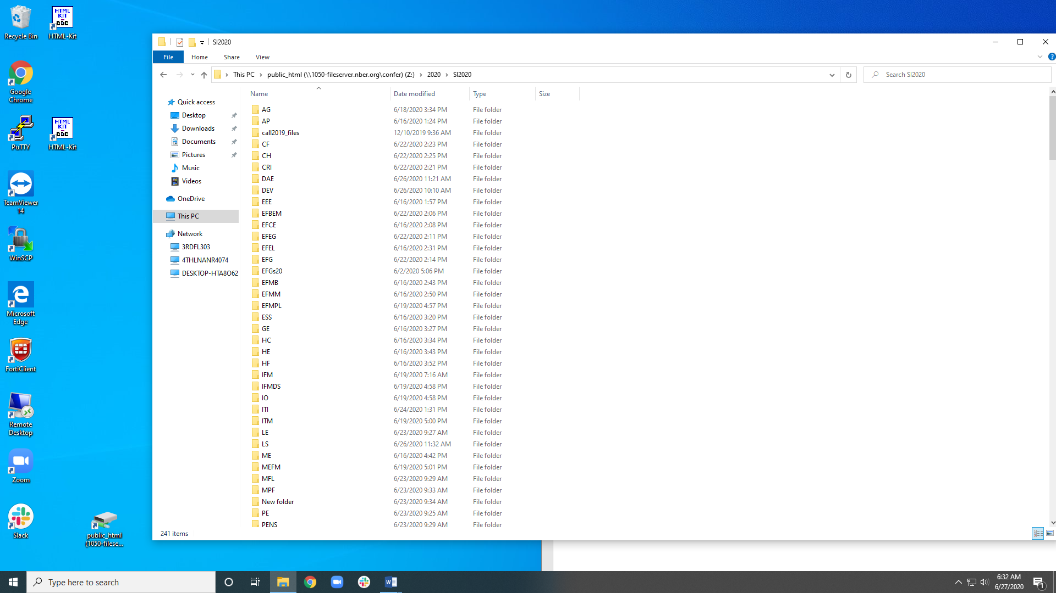

Meeting folder and slides

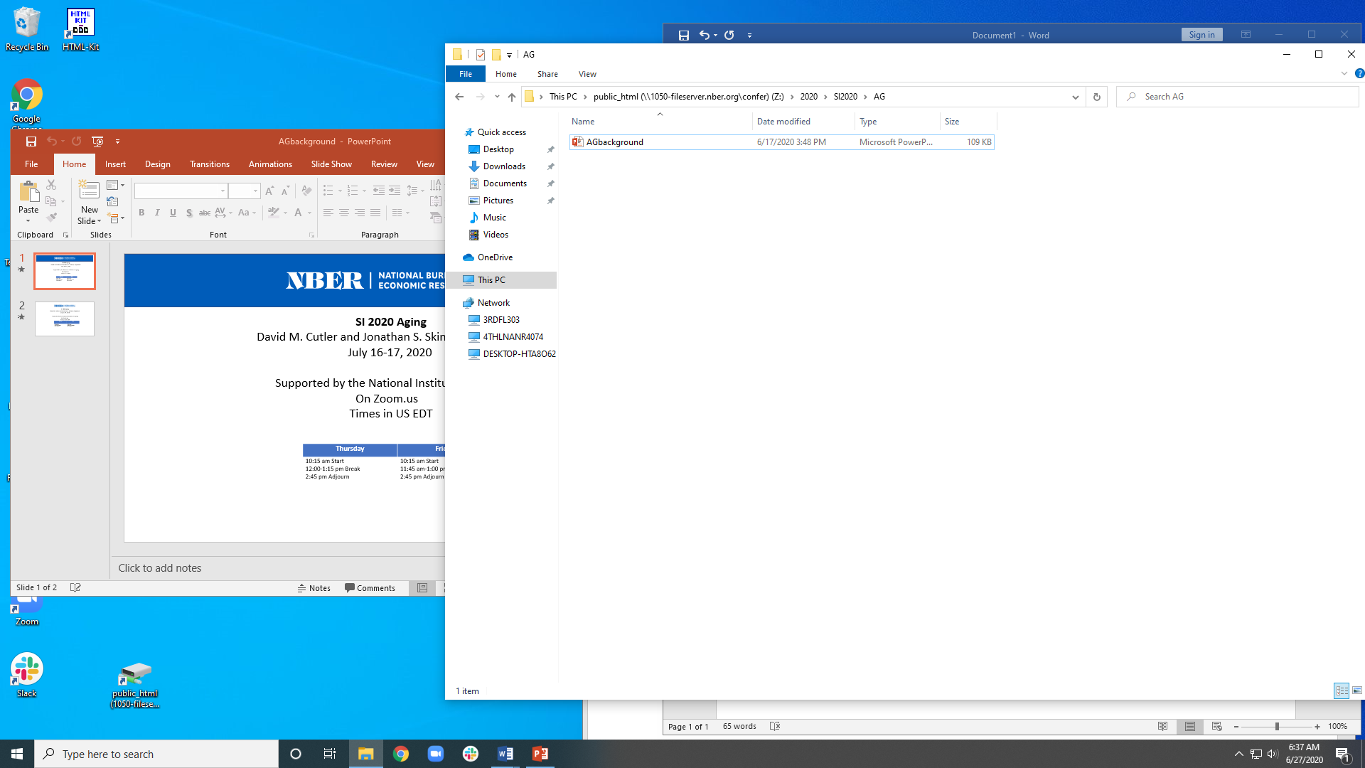

Zoom account with multiple webinars

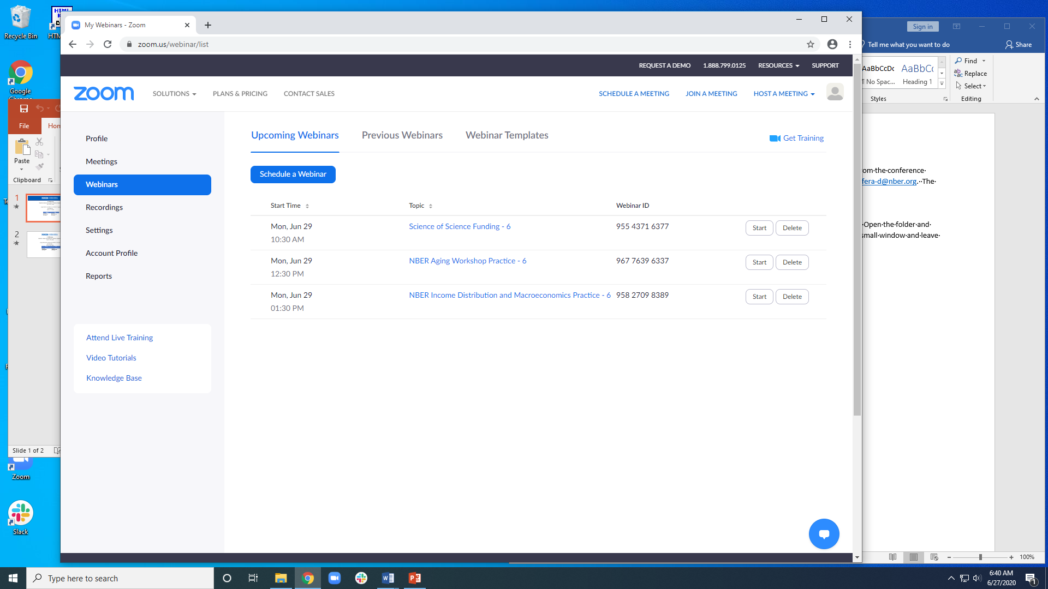

Livestream link

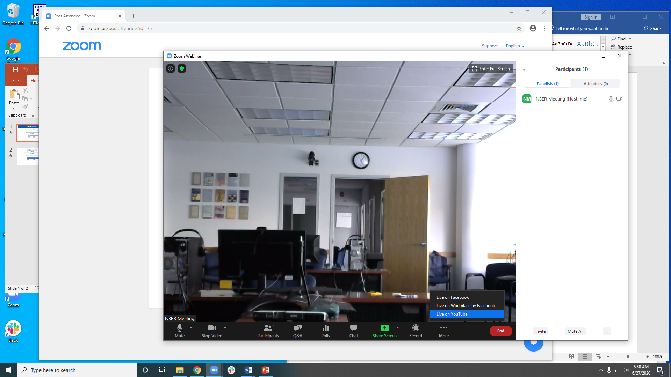

YouTube folder on the confer drive

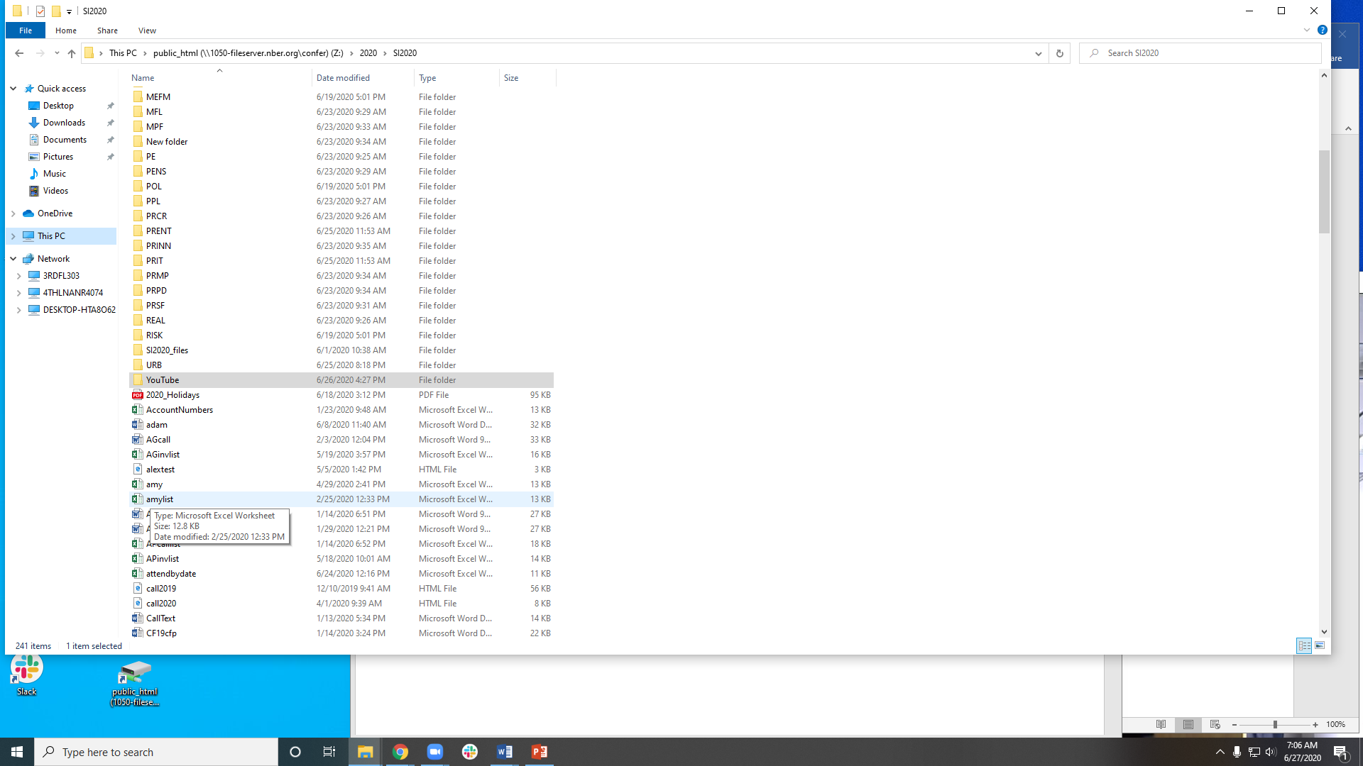

Word document LinksJulyXX

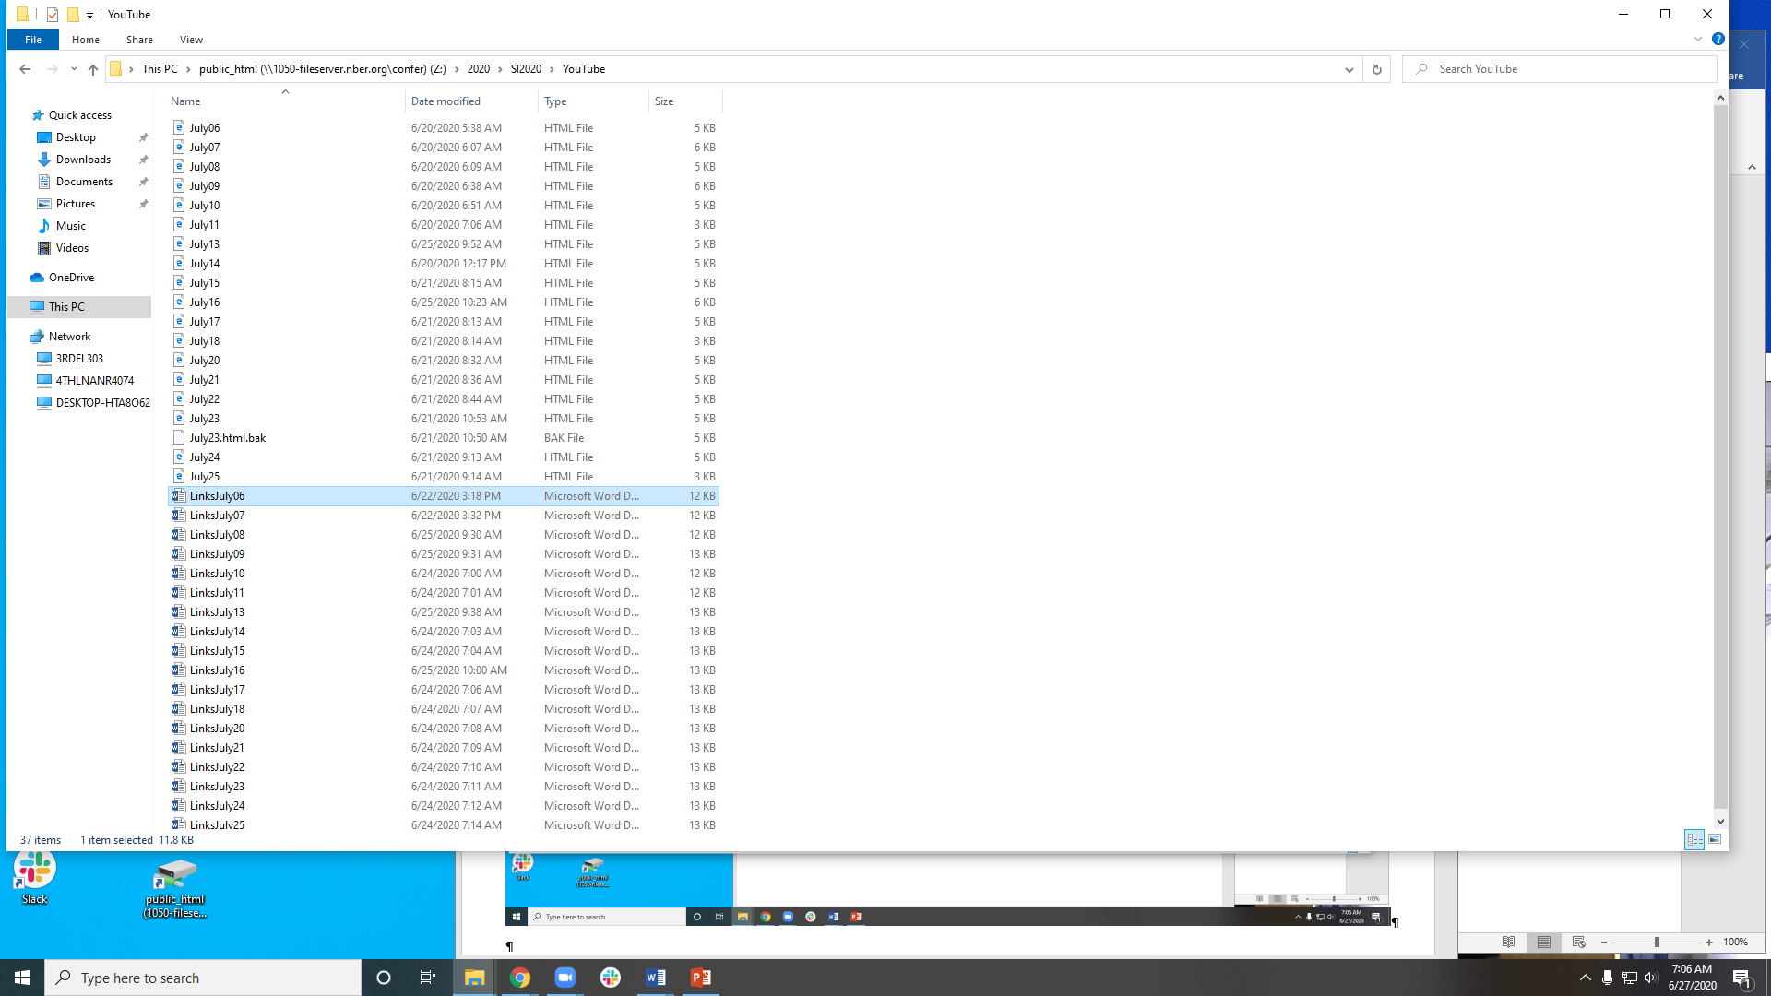

Paste the YouTube url next to the meeting name

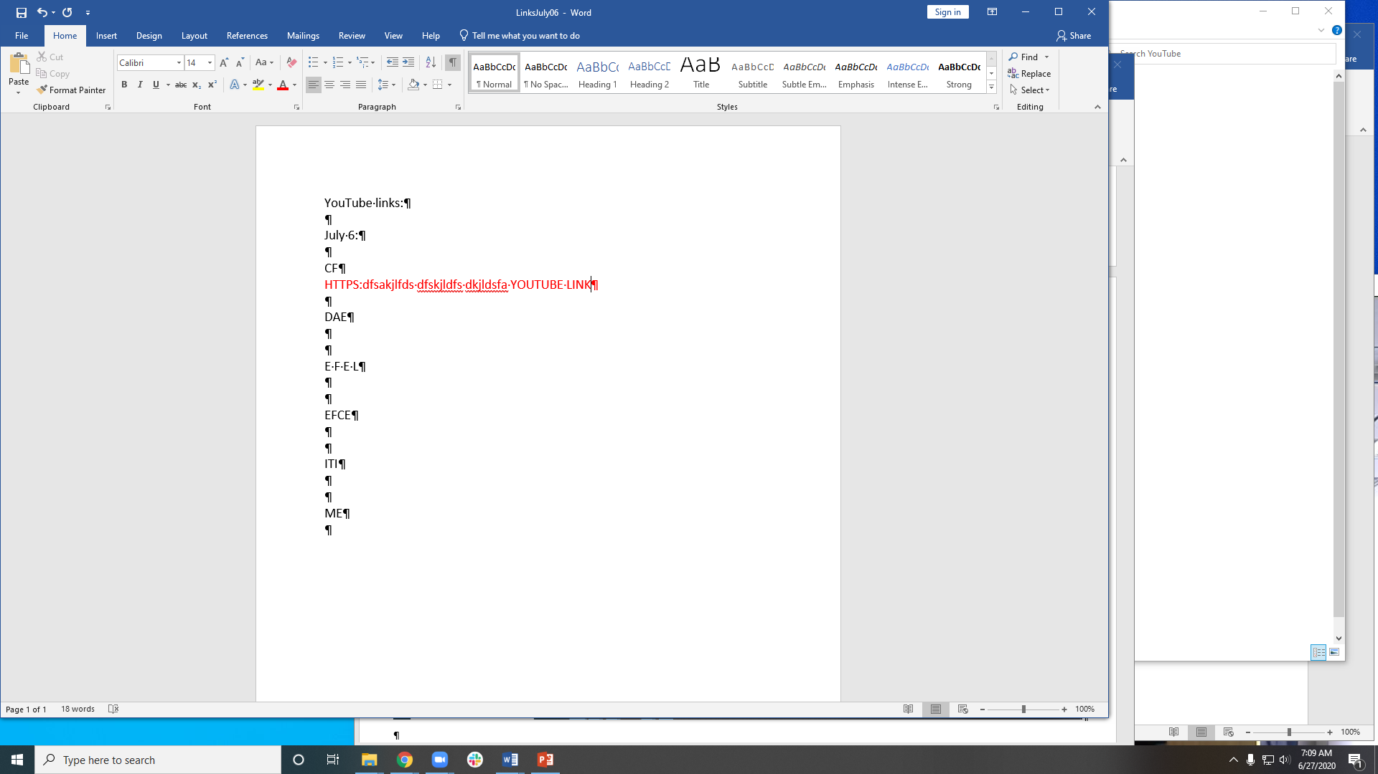

Share screen in the webinar and choose the Powerpoint slides that are open on your desktop

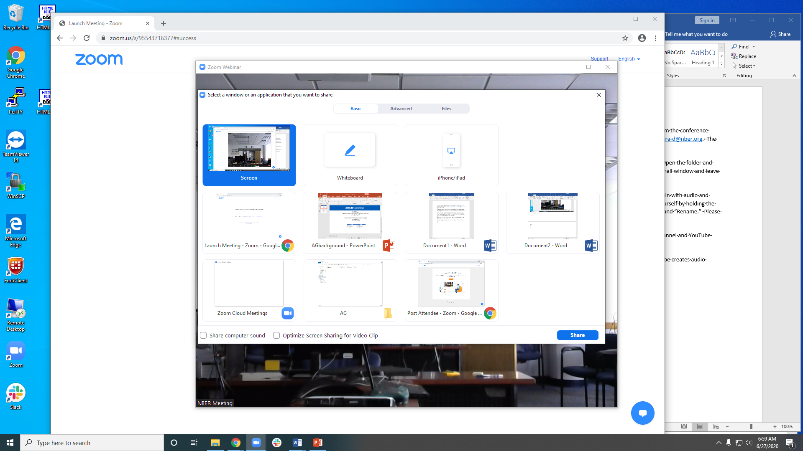

The shared screen in slide show mode, curser in the sharing menu allowing you to click the participant button.

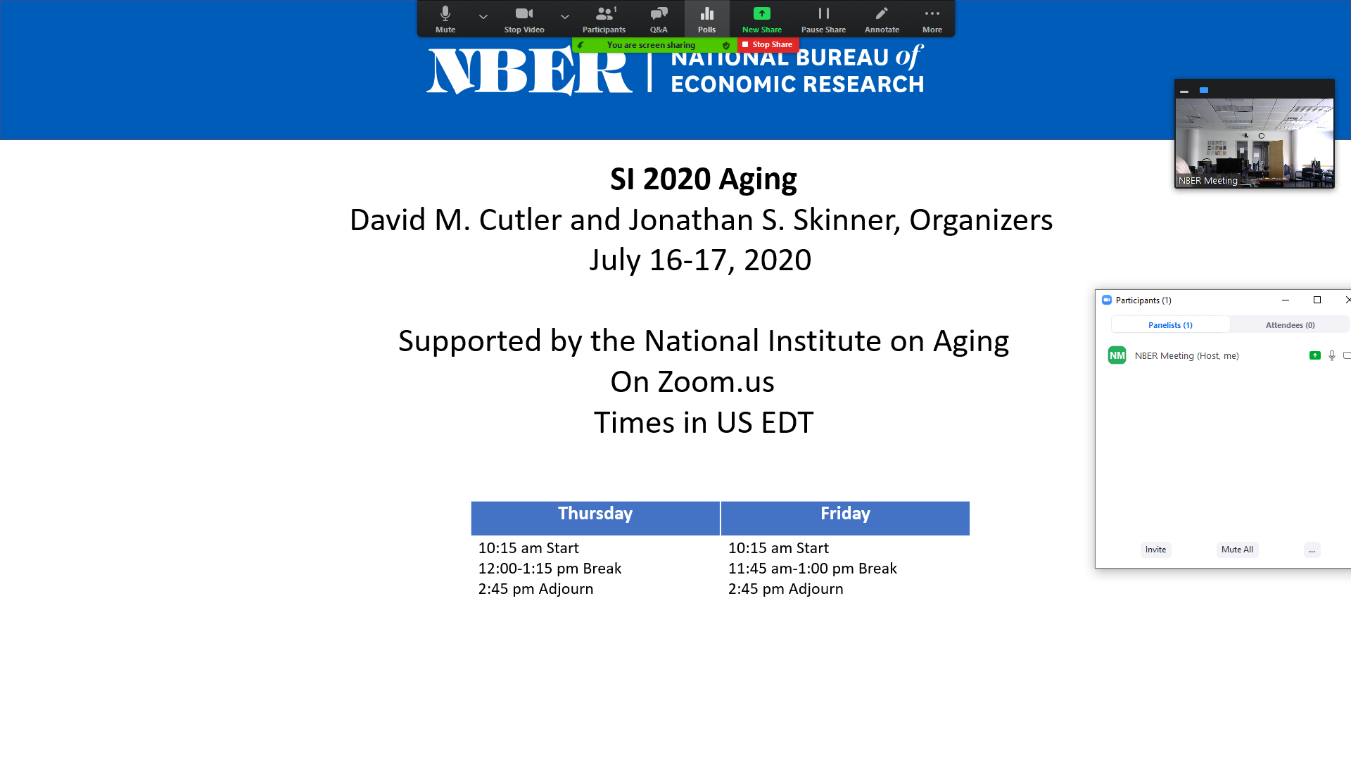

Text